American Wirehaired Pointing Griffon Association
2019 Annual Breeder Referral Form
Rev Date: 12/17/2018

In order for your kennel to be considered for the Breeder Referral program, you must be an AWPGA member in good standing for a minimum of one year PRIOR TO applying. By submitting this executed form, you agree to abide by the
AWPGA Code of Ethics and the Breeder’s Standard Practices.

INSTRUCTIONS For Submitting Electronic membership(s) & Payment(s) can be found on page 3 of this Application

Even if you have previously completed a Breeder Referral Form, YOU MUST COMPLETE A NEW ONE EACH YEAR to remain on the list. Renewals should be submitted by January 31st each year. New applications can be submitted at any time.
PLEASE PRINT LEGIBLY
Name(s):
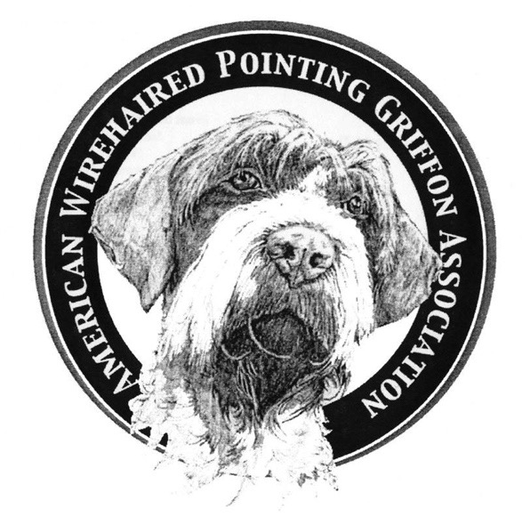
Kennel Name:
If your Kennel is currently on the AWPGA Breeder Referral List, has any of your information changed from last year? Yes No
City: State: Zip: Country:
Home Phone: Cell Phone: Fax:
E-Mail: Website Address:

What does your kennel offer? (Please check all that apply) Puppies Adult Dogs Started Dogs Stud Service
What is the primary focus of your kennel? Show Hunt Performance~ obedience, agility, tracking, etc. Other
Check the homes that you will consider: Non-Hunting Show Hunt Other/Performance~ Service
How long have you been involved with the breed? How long have you been breeding?
How frequently do you have litters? How many litters have you produced?
HEALTH CLEARANCE(S)
COMPLETED BY YOUR KENNEL | OFA | PENNHIP
HIPS
ELBOWS
EYES
THYROID
CARDIAC
K LOCUS
OTHER

Are all of your puppies able to be registered? Yes No
Do you register your litters with AKC? Yes No
Do you register your litters with NAVHDA? Yes No
Are you an AKC Breeder of Merit ? Yes No
Are you a participant of the AKC “Bred with H.E.A.R.T” Program?
Yes No
Is your Breeding Stock Registered with the(AKC)?
Yes No
Do you sell on contract? Yes No

What are the primary provisions of the contract? (Please specify):
Do your puppies receive a health checkup and vaccinations before going to their new homes? Yes No
What method do you use to permanently identify your puppies Microchip? Tattoo (if tattooing, which registry?)
What are your guarantees? (Please specify):
What is your policy regarding replacement/refund?
May prospective owners visit your kennel by appointment? Yes No
If one of your puppies turns up in Rescue/Surrender, are you willing to take it back and/or help with its re-homing? Yes No
Do you agree to SUBMIT YOUR LITTER INFORMATION TO THE AWPGA DATABASE AND provide AWPGA Database information to your puppy owners and encourage them to input their puppy’s information? Yes No

I (we) agree to permanently identify all puppies before they leave my (our) premises. I (we) agree to abide by the AWPGA Code of Ethics. I (we) agree to abide by the AWPGA Breeders’ Standard Practices. I (we) have read and understand the Suggested Guidelines for Breeders. I (we) attest that I (we) am (are) a member(s) in good standing of the AWPGA and that all of the information on this form is truthful.
Please indicate on the 2nd page any comments or special conditions not covered on this form.

Signature(s) of AWPGA Member/Breeder/Kennel Owner(s) Date:

- - - - - - - - - - - - - - - - - - - - - - - - - - - - - - - - - - - - - - - - - - - - - - - - - - - - - - - - -
(for official use only)
Date Received: Form Number:

Rev Date: 12/17/2018

American Wirehaired Pointing Griffon Association
2019 Annual Breeder Referral Form
Rev Date: 12/17/2018

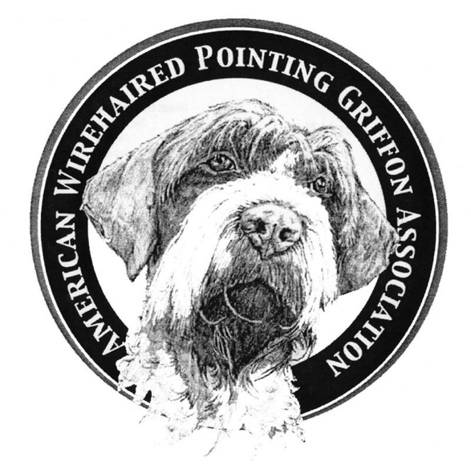
Please list below any other pertinent information you would like to share:

Send completed Form or any questions to: Becky Brannan~ beckybrannan@att.net Cell: 530-906-6678
Or Mail form to: Becky Brannan, AWPGA Breeder Referral Liaison, 14869 Mosswood Lane, Grass Valley CA 95945

(for official use only)

Current year dues paid? Yes No
AWPGA Member in good standing? Yes No
NA Member’s Date of Membership:
Date of Breeder Referral List Eligibility:

(1 Year After Membership was approved by the AWPGA Board as per the By-Laws)

Instructions for Submitting Electronic Membership(s)

- Click Sign In/Register found on the home page of awpga.com
- Click on Membership Instructions
- Click, download, edit/complete the 2019 Membership Application
- Date & E-sign by providing 3 initials of your full name on the signature line
- Save this file to your designated location.
- E-mail this completed form to Garron Riechers @ garron.awpga@att.net
If you are a breeder, you must continue with the following Instructions:

- Click, download, edit/complete the 2019 Breeder Referral Form
- Once completed, save this file to your designated location.
- E-mail this complete form, ALONG with the completed 2019 Membership Application to Becky Brannan @ beckybrannan@att.net
- Your initials on this form confirms that you agree (in it’s entirely) and respect the Breeder’s Standard Practices & Guidelines as well as the Breeder’s Best Practices found at www.awpga.com AND have been a member of AWPGA for 1 FULL Year.

Instructions for Submitting Electronic Payment(s)

- Click on the Shopping Tab found on the www.awpga.com website
- Select the appropriate Membership for you/your famiy
- Mark your appropriate selections ie New, Renewal
- Click View more to Read the Full Disclosure & Agreement
- Click Add to Cart
- Click Check Out
- IN THE NOTE SELECTION BOX, PLEASE provide Full Name of Member(s)
- Complete the Checkout procedure with E-Delivery Information, Payment Information
- Click Place Order to Finalize your order

A confirmation e-mail will be sent to you for your purchase.
If you have questions about your order, contact Garron Riechers at garron.awpga@att.net

