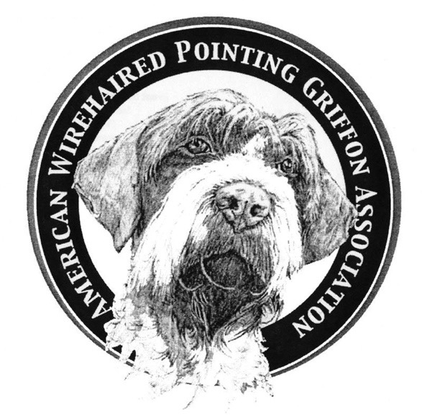
American Wirehaired Pointing Griffon Association
2019 MEMBERSHIP APPLICATION
MEMBERSHIP
Rev Date: 12/17/2018

All memberships expire December 31st and payment of dues is required by January 31, 2019 in order to maintain membership
and to continue receiving your Griffonnier. Dues can be made payable (all funds in US dollars) to AWPGA by check/money order.
Mail this form to: Garron Riechers, Treasurer, 1053 Tanyard Springs Drive, Spring Hill, TN 37174 Cell: 931-241-7474

Instructions for Submitting Electronic Membership(s) & Payment(s) can be found on page 2 of this Application
NOTE TO BREEDERS: A Breeder Referral Form is needed EVERY Year, along with this application.
Send to: Becky Brannan, Breeder Referral Coordinator

(SPONSOR REQUIRED FOR NEW MEMBERS): If you do not have a sponsor, your application is provisional pending approval by the board. You will be contacted by your regional representative. A sponsor may be your breeder, another member of AWPGA, etc
NEW MEMBERSHIP REQUIRED-Sponsor’s Name:
RENEWAL MEMBERSHIP ~ Has any information changed from last year? Yes No

Type of Membership (Check One) $36 US Individual $48 US Household $27 Junior (Under 18 years)
$48 Canadian & International Individual $54 Canadian & International Individual
PLEASE PRINT LEGIBLY
PRIMARY MEMBER: 2ND MEMBER, IF HOUSEHOLD MEMBERSHIP
Name: Name:
E-Mail: E-Mail :
Home Phone: Cell Phone: Home Phone: Cell Phone:
Fax: Fax:
Street Address:
City: State: Zip: Country:
Occupation: Occupation:

Kennel Name (if applicable): Website Address

Is is ok to include all of your contact information in the membership directory? Yes No
If not, specify what information you DO NOT want included:

What are your Interests? Field Conformation Obedience Tracking Agility Other
Tell us how you would like to volunteer. Are you interested in joining a committee?
Communications Education Event Finance Rescue
Would you be interested in in helping with any of the following?
Specialty Committee in your region Field Tests in your area Presenter for Judge’s Education Rescue
Website Ways & Means Make something/donate for Specialty Auction Health & Genetics Griffonnier Staff
Write an article for the Griffonier (Subject):
I could help with the following:
CONSIDER DONATION TO ONE OF THE FOLLOWING FUNDS:
HEALTH & GENETICS FUND
RESCUE FUND
NATIONAL SPECIALTY~TROPHY FUND
EDUCATION FUND
AWARDS PROGRAM
KORTHALS CUP FUND
SPECIALTY FUND
GENERAL FUND
SELECTED MEMBERSHIP FEE
TOTAL PAYMENT: | $$\$ FORMTEXT$$

I would like to apply/renew my membership with the American Wirehaired Pointing Griffon Association. I certify that I am 18 years of age or older and agree to abide by the Constitution and Bylaws of the AWPGA and the AWPGA Code of Ethics which can be found on AWPGA’s website.

Signature/E-signed Initials Date:
(for official use only)
Date Received: Form Number:

Instructions for Submitting Electronic Membership(s)

- Click Sign In/Register found on the home page of awpga.com
- Click on Membership Instructions
- Click, download, edit/complete the 2019 Membership Application
- Date & E-sign by providing 3 initials of your full name on the signature line
- Save this file to your designated location.
- E-mail this completed form to Garron Riechers @ garron.awpga@att.net
If you are a breeder, you must continue with the following Instructions:

- Click, download, edit/complete the 2019 Breeder Referral Form
- Once completed, save this file to your designated location.
- E-mail this complete form, ALONG with the completed 2019 Membership Application to Becky Brannan @ beckybrannan@att.net
- Your initials on this form confirms that you agree (in it’s entirely) and respect the Breeder’s Standard Practices & Guidelines as well as the Breeder’s Best Practices found at www.awpga.com AND have been a member of AWPGA for 1 FULL Year.

Instructions for Submitting Electronic Payment(s)

- Click on the Shopping Tab found on the www.awpga.com website
- Select the appropriate Membership for you/your famiy
- Mark your appropriate selections ie New, Renewal
- Click View more to Read the Full Disclosure & Agreement
- Click Add to Cart
- Click Check Out
- IN THE NOTE SELECTION BOX, PLEASE provide Full Name of Member(s)
- Complete the Checkout procedure with E-Delivery Information, Payment Information
- Click Place Order to Finalize your order

A confirmation e-mail will be sent to you for your purchase.
If you have questions about your order, contact Garron Riechers at garron.awpga@att.net

