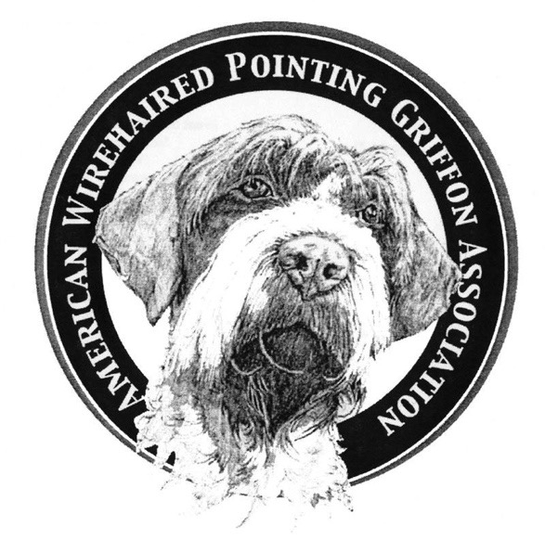
American Wirehaired Pointing Griffon Association
2021 MEMBERSHIP APPLICATION
Rev Date: 12/20/2020

All memberships expire December 31st and payment of dues is required by January 31, 2021 in order to maintain membership
and to continue receiving your Griffonnier magazine. Dues can be made payable (all funds in US dollars) to AWPGA by check/money order.

Print, Complete and then Mail this form along with your payment to:
SHERYL DIERENFIELD, 7751 EAST STATE HWY 14, FORT COLLINS CO 80524

(SPONSOR REQUIRED FOR NEW MEMBERS): If you do not have a sponsor, your application is provisional pending approval by the board. You will be contacted by your regional representative. A sponsor may be your breeder in good standing with AWPGA, another member of AWPGA, etc.

NEW MEMBERSHIP REQUIRED-Sponsor’s Name:

RENEWAL MEMBERSHIP ~ Has any information changed from last year? Yes No

Type of Membership (Check One) $36 US Individual $48 US Household $27 Junior (Under 18 years)
$48 Canadian & International Individual $54 Canadian & International Individual
PLEASE PRINT LEGIBLY
PRIMARY MEMBER: 2ND MEMBER, IF HOUSEHOLD MEMBERSHIP
Name: Name:
E-Mail: E-Mail :
Home Phone: Cell Phone: Home Phone: Cell Phone:
Fax: Fax:
Street Address: Street Address:
City: State: Zip: City: State: Zip:
Country: Country:
Occupation: Occupation:

Is is ok to include all of your contact information in the membership directory? Yes No

If not, specify what information you DO NOT want included:

What are your Interests? Field Conformation Obedience Tracking Agility Other

Tell us how you would like to volunteer. Are you interested in joining a committee?
Communications Education Event Finance Rescue Junior Program
Would you be interested in helping with any of the following?
Specialty Committee in your region Field Tests in your area Presenter for Judge’s Education Rescue Junior Program

Website Ways & Means Make something/donate for Specialty Auction Health & Genetics Griffonnier Staff

Write an article for the Griffonier (Subject):

I could help with the following:

CONSIDER DONATION TO ONE OF THE FOLLOWING FUNDS:
HEALTH & GENETICS FUND
RESCUE FUND
NATIONAL SPECIALTY~TROPHY FUND
JUNIOR PROGRAM
EDUCATION FUND
AWARDS PROGRAM
KORTHALS CUP FUND
SPECIALTY FUND
GENERAL FUND
SELECTED MEMBERSHIP FEE
TOTAL PAYMENT: | $$\$ FORMTEXT$$

IF YOU ARE NOT A BREEDER, PLEASE FINALIZE THIS FORM BY MOVING DOWN TO THE HIGHLIGHTED AREA.

NOTE TO BREEDERS:

IF YOU ARE A BREEDER THAT WOULD LIKE TO BE PLACED ON THE BREEDER REFERRAL LIST (AND YOU HAVE BEEN
A MEMBER IN GOOD STANDING WITH THE AWPGA FOR A MINIMUM OF 12 MONTHS PRIOR TO YOUR APPLYING
TO THE BREEDER REFERRAL PROGRAM) PLEASE COMPLETE THE FOLLOWING INFORMATION FOR YOUR CONSIDERATION:

Kennel Name (if applicable): Website Address (if applicable):

Contact Name: E-mail Address:

Street Address: City, State, Zip Code:

We Offer the Following: Puppies Started Dogs Stud Service Adult Dogs Other:

Preferred Homes: Show Hunt Pet Service Performance Other:

Our Kennel: Participates as an AKC Breeder of Merit
Participates in the AKC BRED by H.E.A.R.T.
Sells All Puppies On Contract
Registers All Puppies with AKC
Registers All Puppies with NAVHDA
Other:

I have reviewed the Code of Ethics, the Breeder’s Standard Practices & the Breeders’ Best Practices
By submitting and signing this executed form, I Agree to abide accordingly.

I would like to apply/renew my membership with the American Wirehaired Pointing Griffon Association.

I certify that I am 18 years of age or older and agree to abide by the Constitution and Bylaws of the AWPGA
and the AWPGA Code of Ethics which can be found on AWPGA’s website.

Signature Date:

Date Received: Form Number:
(for official use only)

